

QATAR AIRWAYS HOLDS ANNUAL EMERGENCY EXERCISE TO TEST AIRLINE PREPAREDNESS

27 February 2013

Doha, QATAR – Qatar Airways has held its Annual Emergency Exercise to conduct a realistic assessment of the airline’s preparedness in the event of a real life aircraft emergency.

The exercise involved a Qatar Airways aircraft experiencing an emergency shortly after take-off from one of its worldwide destinations.

Almost 200 staff members including key senior executives and Qatar Airways Chief Executive Officer Akbar Al Baker took part in the exercise in Doha which was coordinated by the airline’s Group Safety and Security, Contingency Planning team. A special Emergency Exercise Task Force was formed with representatives from several departments across the company.

Upon exercise notification, almost every aspect of the emergency response was activated, including the Qatar Airways Group Emergency Control Centre, Operations Control Centre, Deployed Response Group, Special Assistance Team and Telephone Enquiry Centre.

Simulated television news broadcasts of the unfolding emergency and black box tapes were created and viewed by staff in the Emergency Operations Centre, to give the activity an aspect of realism and immediacy.

Al Baker said every staff member at the airline must be prepared for the unlikely event of an emergency.

“In the event of a real life emergency everyone will be in involved in responding in some way, which is why it remains a top priority of this company to ensure all staff are well prepared and aware of their responsibilities,” he said.

“Over the past couple of weeks, all departments across the airline have been busy preparing their teams for this exercise.

“While there is always room for improvement, I am confident that Qatar Airways is sufficiently prepared for such a situation and we look forward to evaluating today’s exercise and highlighting where our strengths lie and areas where improvements can be made across the company.”

Arab Air Carriers Organisation (AACO) Secretary General Abdul Wahab Teffaha, who was an observer at the exercise, said: “It was a very encouraging experience to see one of our member airlines take emergency exercises very seriously.

“It makes me proud to see Qatar Airways is prepared to deal with such eventualities and I hope other airlines take notice of the importance of training and preparedness for employees across the company.”

-ends-

IMAGES

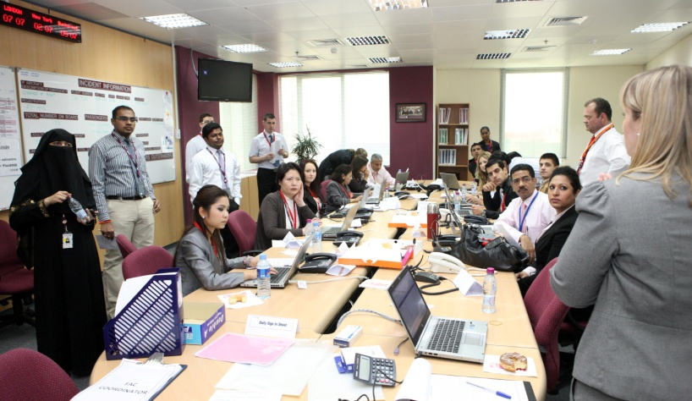
Click here for image
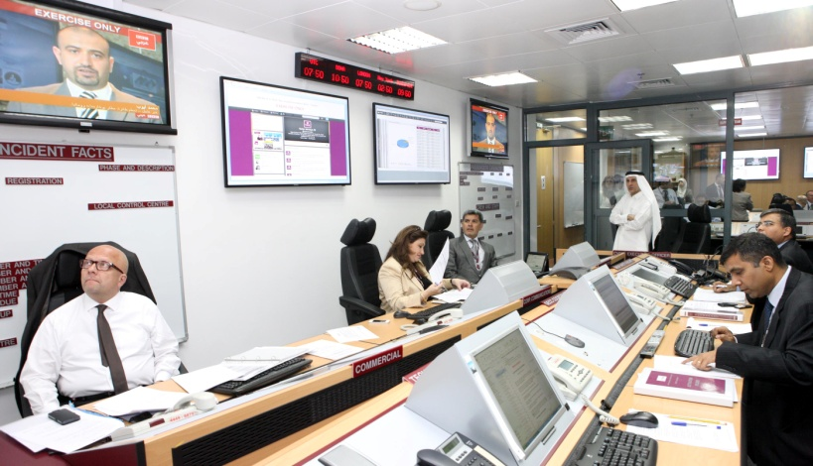
Click here for image

Click here for image

Notes to Editors:

Qatar Airways currently has orders worth over US$50 billion for more than 250 aircraft, including Boeing 787s, 777s, Airbus A350s, A380s and A320 Family of aircraft. In addition to winning Skytrax’s prestigious Airline of the Year 2011 and 2012, Qatar Airways was named Best Airline in the Middle East for the seventh year in a row, and its Premium Terminal at Doha International Airport was named Best Premium Service Airport for the second consecutive year in 2012. Skytrax is the only global independent passenger survey monitoring airline standards and is considered the ultimate benchmark for excellence in the airline industry. In October 2012, Qatar Airways became the first of the major Gulf carriers to officially join a global alliance having been invited into the oneworld group. For more information, visit www.qatarairways.com

FOR QATAR AIRWAYS CORPORATE IMAGES VISIT THE FOLLOWING WEBSITE:

(PLEASE NOTE: Select Images And Open On Desktop)
FTP URL: ftp://ftp.qatarairways.com.qa
User Name: qrcomms
Password: O4Au2006

For further information
Qatar Airways Group, Corporate Communications Department
Tel: +974 44302072, Fax: +974 44302069
E-mail: qrmedia@qatarairways.com.qa / Website: www.qatarairways.com

